**PIZZA SALES SQL QUERIES**

**1.TOTAL REVENUE**

Select Cast(sum(total_price) as decimal(10,2)) as Total_Revenue from pizza_sales;

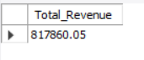

**2. AVERAGE ORDER VALUE**

SELECT cast((Sum(total_price)/count(distinct(order_id)))as decimal(10,2))as Avg_Order_Value from pizza_sales;

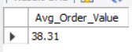

**3. TOTAL PIZZAS SOLD**

Select sum(quantity) as Total_Pizzas_Sold from pizza_sales;



**4. TOTAL ORDERS**

Select count(distinct(order_id)) as Total_Orders from pizza_sales;



**5. AVERAGE PIZZAS PER ODER**

Select Cast(sum(quantity)/count(distinct(order_id))as decimal(10,2)) as Avg_Pizzas_Per_order from pizza_sales;

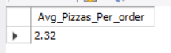

**6. DAILY TREND FOR TOTAL ORDERS**

SELECT DATENAME(DW, order_date) AS order_day, COUNT(DISTINCT order_id) AS total_orders

FROM pizza_sales

GROUP BY DATENAME(DW, order_date)

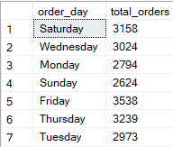

**7. MONTHLY TREND FOR ORDERS**

SELECT dateName(MONTH, order_date) AS order_day, COUNT(DISTINCT order_id) AS total_orders

FROM pizza_sales

GROUP BY DATEName(MONTH, order_date)

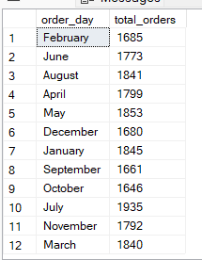

**8.Percentage Sales by Pizza Category**

Select pizza_category, Cast(Sum(total_price)*100/ (select sum(total_price) from pizza_sales) as decimal (10,2)) as Percentage_total_sales

from pizza_sales

group by pizza_category

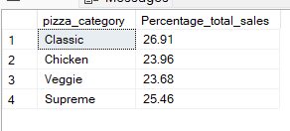

**8.1 PERCENTAGE SALES BY PIZZA CATEGORY AS PER MONTH**

Select pizza_category, Cast(Sum(total_price)*100/ (select sum(total_price) from pizza_sales where MONTH(order_date)= 1) as decimal (10,2))

as Percentage_total_sales from pizza_sales

where MONTH(order_date)=1

group by pizza_category

**9. PERCENTAGE OF SALES BY PIZZA SIZE**

Select pizza_size, Cast(Sum(total_price)*100/ (select sum(total_price) from pizza_sales)

as decimal(10,2))as Percentage_total_sales

from pizza_sales

group by pizza_size

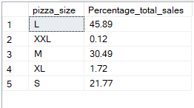

**9.1 PERCENTAGE OF SALES BY PIZZA SIZE AS PER YEARLY QUARTER**

Select pizza_size, Cast(Sum(total_price)*100/ (select sum(total_price) from pizza_sales where DATEPART(quarter,order_date)=1) as decimal(10,2))

as Percentage_total_sales

from pizza_sales

where DATEPART(quarter,order_date)=1

group by pizza_size

order by Percentage_total_sales Desc

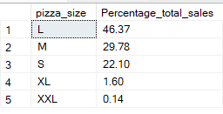

**10*. PERCENTAGE QUANTITY OF PIZZA SOLD AS PER PIZZA CATEGORY**

Select pizza_category, Sum(quantity)*100/ (select sum(quantity) from pizza_sales)

as Percentage_total_Quantity from pizza_sales

group by pizza_category

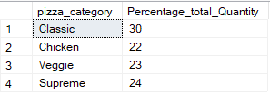

**11. TOP 5 BEST SELLERS BY REVENUE, TOTAL QUANTITY AND TOTAL ORDERS**

**11.1 TOP 5 BEST SELLERS BY REVENUE**

Select TOP 5 pizza_name,sum(total_price) as Total_sales from pizza_sales

group by pizza_name

order by Total_sales desc;

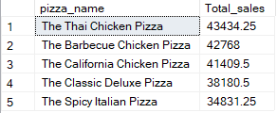

**11.2 TOP 5 BEST SELLERS BY TOTAL QUANTITY**

Select Top 5 pizza_name,sum(quantity) as Total_Quantity from pizza_sales

group by pizza_name

order by Total_Quantity DESC;

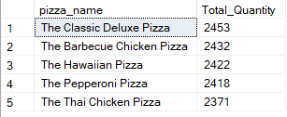

**11.3 TOP 5 BEST SELLERS BY TOTAL ORDERS**

Select Top 5 pizza_name,Count(DISTINCT order_id) as Total_Orders from pizza_sales

group by pizza_name

order by Total_Orders DESC;

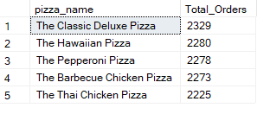

**12. BOTTOM 5 BEST SELLERS BY REVENUE, TOTAL QUANTITY AND TOTAL ORDERS**

**12.1 BOTTOM 5 BEST SELLERS BY REVENUE**

Select TOP 5 pizza_name,sum(total_price) as Total_sales from pizza_sales

group by pizza_name

order by Total_sales ASC;

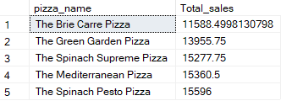

**12.2 BOTTOM 5 BEST SELLERS BY TOTAL QUANTITY**

Select Top 5 pizza_name,sum(quantity) as Total_Quantity from pizza_sales

group by pizza_name

order by Total_Quantity ASC;

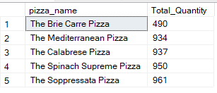

**12.3 Bottom 5 BEST SELLERS BY TOTAL ORDERS**

Select Top 5 pizza_name,Count(DISTINCT order_id) as Total_Orders from pizza_sales

group by pizza_name

order by Total_Orders ASC;

